Welcome!
Date
Name
Spouse
Address
City
State Zip _________
Email

Please Contact By
❑ Card  Phone  Visit

Telephone Best Time to Call
Home ______________
Work ______________

Guest: First Time Second Time
Are you a church member: yes no
Church
City, State

Circle Appropriate Age/Grade Group(s)
Preschool: Ages: B-1 2-3 4-5
Children: Grades: K 1 2 3 4 5 6
Youth: Grades: 7 8 9 10 11 12
Adults: Ages:18-29 30s 40s 50s 60s+

How did you learn about our church?
Newspaper Friend Yellow Pages Mail
Other

I am a guest of:

New in the Community? Yes No
Names & ages of children at home

Weekly Service & Activity Schedule

June 8, 2014
9:45 a.m. Sunday School
11:00 a.m. Morning Worship Service
12:00 a.m. Graduation Banquet – Covered Dish
6:00 p.m. Evening Worship-Business Meeting

Week of June 9-15

Wednesday, 7:00 p.m. Youth Activities
Wednesday, 6:45 p.m. Adult Prayer & Bible Study
Thursday , 10:00 a.m. Adult Fellowship
SPECIAL NOTE: MEALS ON WEDNESDAY EVENING BEFORE SERVICES ARE BEING DISCONTINUED FOR THE SUMMER MONTHS
Rachel Cook
Alexis Fisher
Morgan Halvorson
Cody Ruthven
Hunter Wilson

For I know the plans I have for you, declares the Lord, plans to prosper you and not to harm you, plans to give you hope and a future. Jeremiah 29:11


Upcoming Events
June

12 Adult Fellowship
15 Father’s Day
22 (covered dish) Wesley & Holly Seigmund Wedding Shower
26 Adult Fellowship
29 Birthdays and Anniversaries

Birthday & Anniversary Recognitions will occur on the final Sunday of each month.

Knobbs Springs Baptist Church

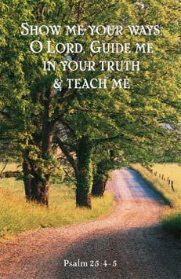

June 8, 2014

Church Information:

KnobbsSpringsBC.com KnobbsSpringsBaptist@gmail.com
1662 CR 305, McDade, Texas 78650 512-273-2743
Brother Dwight Reagan 512-247-6448

